2D GAME DEVELOPMENT REPORT

KURT ABANO

[STUDENT ID: 24783569]

Table of Contents

Version one 3

Scrolling background 3

Version 2 7

Inheritance and Polymorphism 7

Implementing an array list 13

Game over screen 16

Restarting game 17

Collectable object 18

Save and read score (file handling) 20

Version 3 24

Adding a Player class and player aniamtions 24

Animations for obstacles and collectables 29

Death animation 31

# Version one

## Scrolling background

For this game the first thing I wanted to implement was a background that moves depending on the arrow keys pressed.

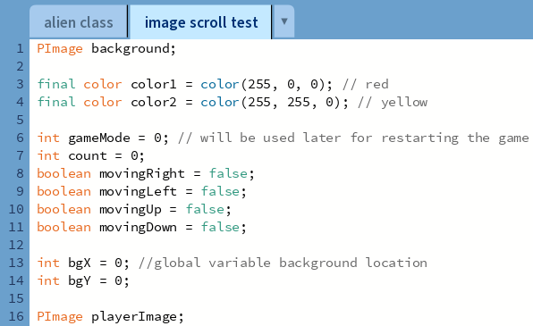  
The image above shows the global variables I’ll be using. The important variables to take note of are the bgX, bgY and the movingRight left up down.

I am going to have it so that when any arrow key is pressed the Boolean values change to true. In my void draw, I’ll have an if statement where if the movingRight, left, up or down is true then bgX and bgY will increment by a set amount. This will move the background

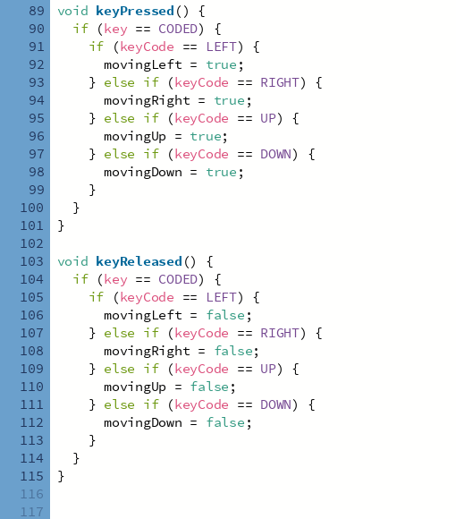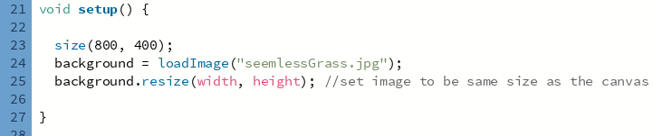  
using a generic grass jpeg for testing

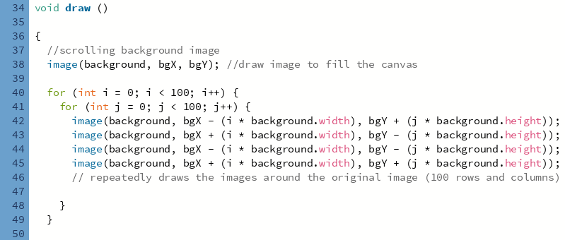

My draw method pastes an image over 100 rows and columns so that when the character moves it looks as if the background is continuously looping.

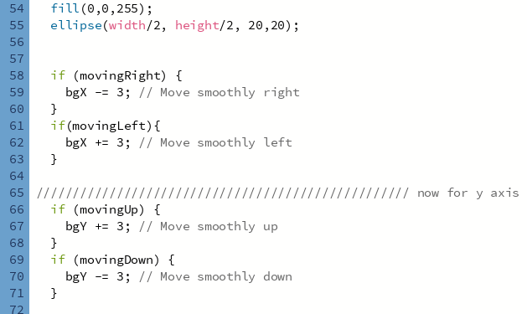

Stationary ellipse is a placeholder for the player.

The if statements will determine if the background should move. If any of them are true, then bgX and bgY will increment appropriately which will move the background.

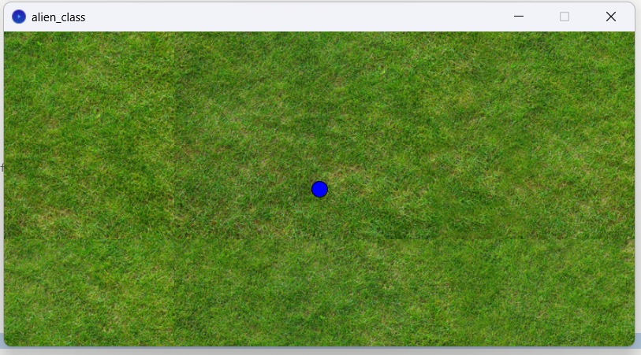

This the background the seams are where the other pasted images are. Pressing the arrow keys moves the background.

After this I made my first obstacle that moves.

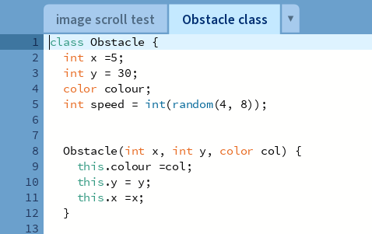

Takes in color as a parameter and has a random speed.

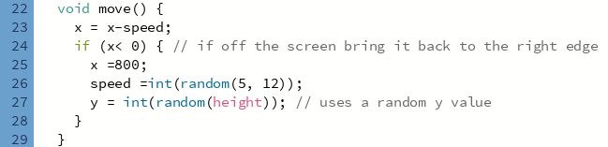

Has a method that moves it horizontally. Once it moves off the screen it respawns at a different y value. (movement is temporary, this will be changed).

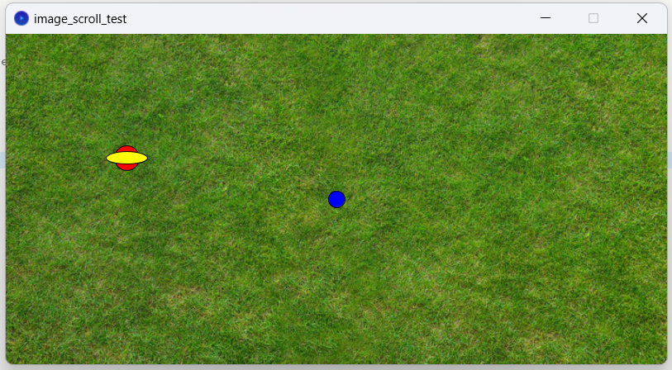

Version 2  
Features to add:

* Movement update
* Array list
* Inheritance and polymorphism
* Collision
* Stationary objects
* Restarting

## Inheritance and Polymorphism

Updated my Obstacle class structure made Obstacle a superclass. Created MovingObstacle and StationaryObstacle classes to inherit from it.

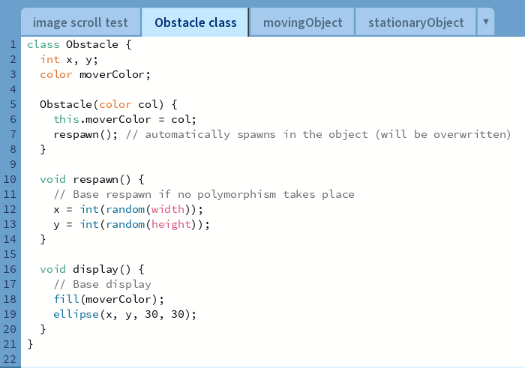

movingObject

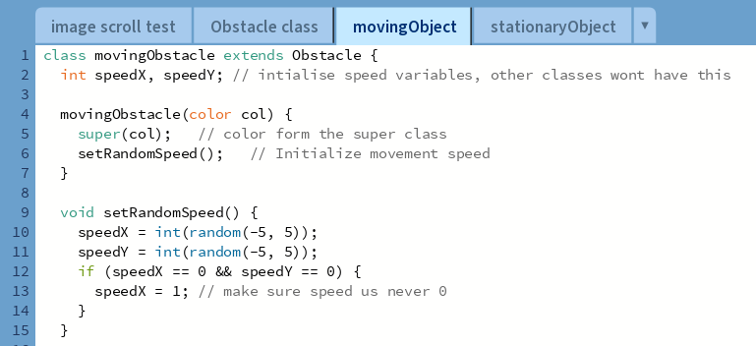

Takes color from the super class. I created a method to set the speed randomly. This function will be called every time the object respawns. This also determines the direction the objects moves in as negative numbers are included

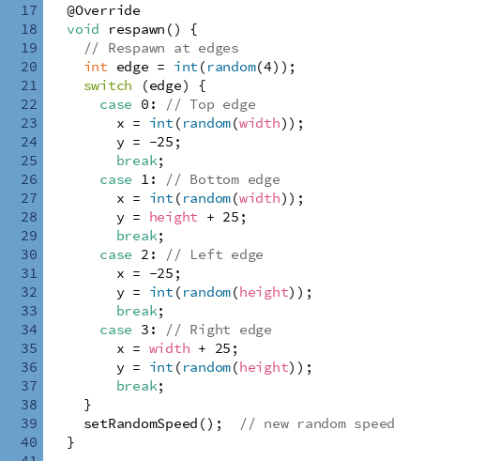

This respawns method overrides the one in the super class. When the object exits the screen, it will respawn randomly at one of the edges of the screen.

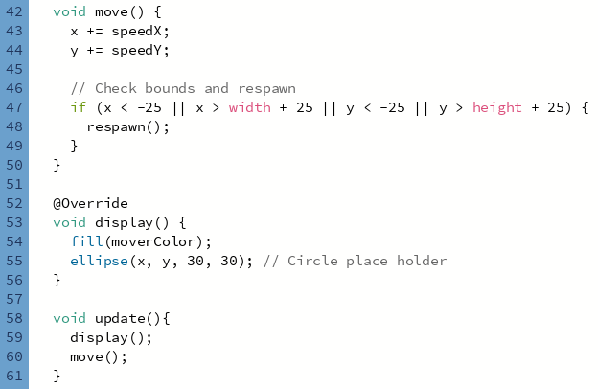  
  
Our move function does not need to overwrite anything as this method is exclusive to this class. In our previous move function, the object would only move horizontally but this one can also mover vertically. The direction is determined on whether speedX or speedY is positive or negative

  
This checks if the object exits the screen, then it recalls the respawn method.

stationaryObject  
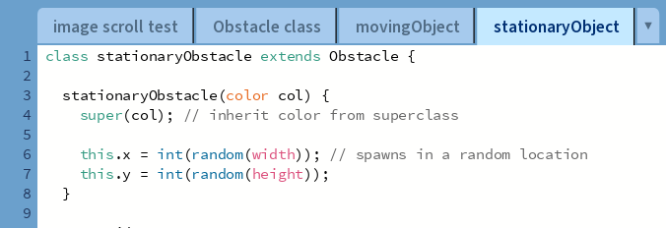  
inherits color and has a random x and y.

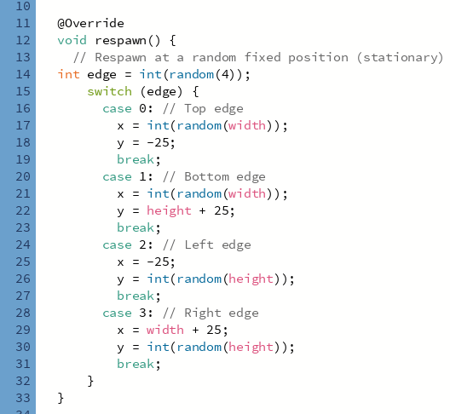  
Respawn method is overwritten again (Polymorphism). The difference between this and the one in movingObjects is that speed isn’t changed as this class doesn’t have a speed attribute

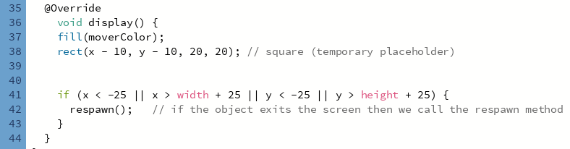  
As this is a different class the display method is overwritten (Polymorphism) so that we can distinguish between the two objects (moving and stationary classes).   
This class also doesn’t have a move method

Running my program:

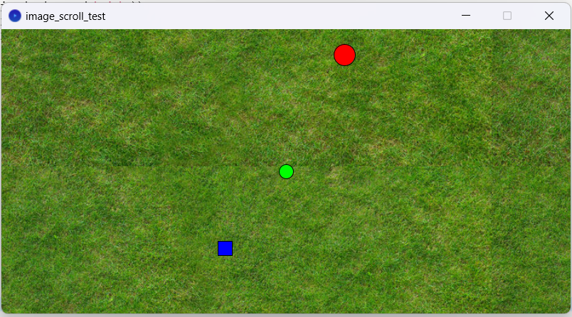  
blue represents the stationary obstacles  
red represents the moving obstacles

Green is the player character (stays in the middle of the screen)

The respawn methods work correctly once these two objects are off the screen they respawn in a different edge. The moving object also moves in a random direction as speedX and speedY are random and can be negative or positive.

## Implementing an array list

Right now, we only have two obstacles on the screen. My game will need more than that, therefore, I’ll be using an array list to store any amount of stationary and moving obstacles

Inside main:

  
This initializes my arrays. Here I decided to make an array that can hold 10 items

Inside void setup:

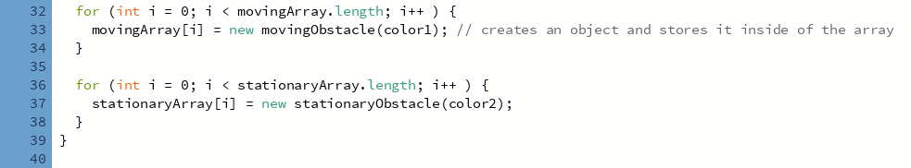  
These four loops create the objects and store them inside of their arrays. Different colors are passed into them as well.

In my void draw:

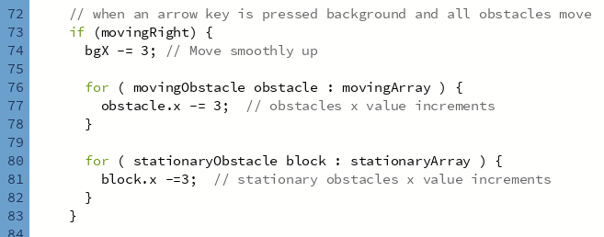

Since we are using an array list, we need each obstacle to move when the player moves, I have done this by using enhanced for loops

Another loop is used below to update all objects in the array



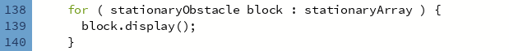

Testing my program:

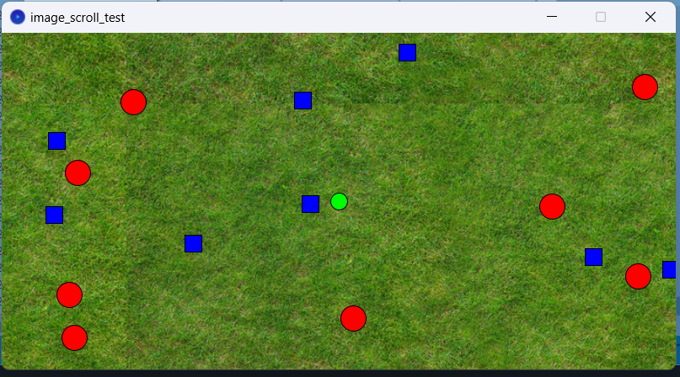  
The test was successful. Multiple objects from the array list is correctly displayed.  
  
  
Collision  
Now I am going to add collision so that when any obstacle hits the player then the game stops.

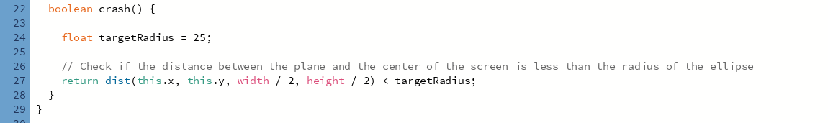  
This is the method I coded to return the distance between the current object and the player.  
Note that as of right now there is no player class, but we do know that the player will always be in the middle of the screen.

This method will be placed in the super class as both stationary and moving obstacles will inherit this method.  
  
Back in main:

In void draw, we will continuously check whether a collision has happened. This check happens for all objects inside my arrays. I have done this by using an enhanced loop. An if statement will change gamemode to 1 if a collision occurs.

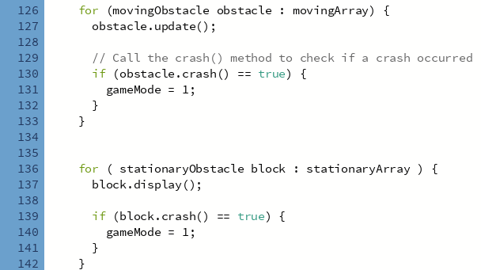  
I also changed my program so that void draw only moves the bakcgrounds and objects if gamemode is 0. This way when a crash occurs the program will stop calling the update/ display methods for my objects effectively removing them from the screen

## Game over screen

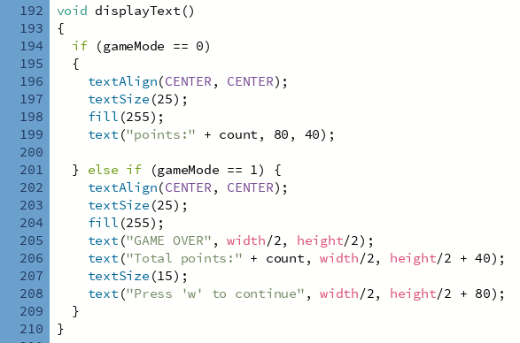

This function will be called in void draw. It will display points and when a collision occurs (ie when gamemode becomes 1) new text is displayed

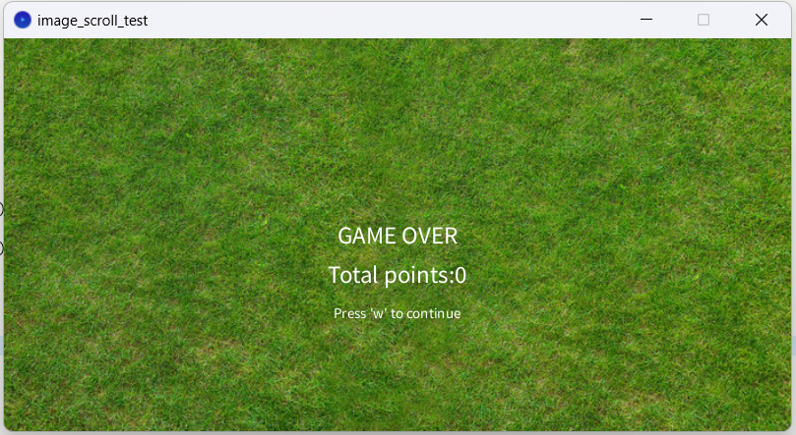  
This is what is displayed when a collision occurs

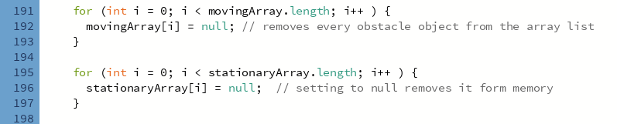

When a game over occurs I turn all my objects in my array list to null. Removing them from memory.

## Restarting game

Now I am going to implement a feature where when the game ends, we can restart it by pressing ‘w’

To do this I added an if statement in the void keyReleased function for when ‘w’ is pressed and gameMode is 1, we can restart the game.

The code below shows the reinitialization of my obstacle objects. This will spawn new objects in different locations.

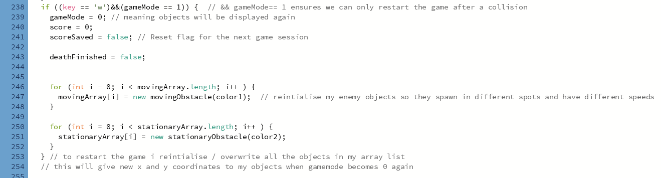

## Collectable object

I decided to add a collectable class that will spawn collectable objects in my game. Collecting them will increment your score / points.  
  
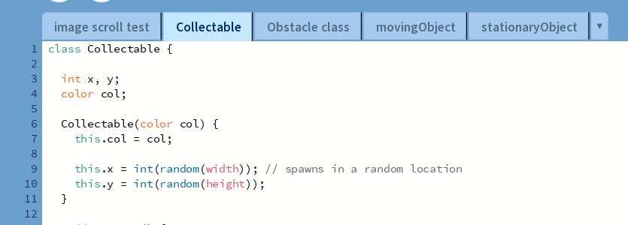

This class has a respawn method identical to the obstacle class.  
  
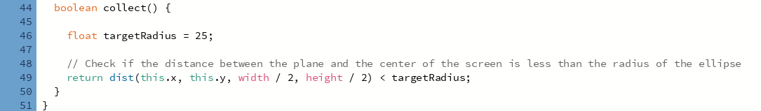  
similar to the crash Boolean method, this method determines whether the player is touching the collectable.  
  
Back in main inside void draw:

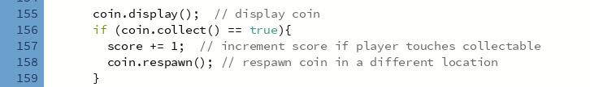  
note that once the player collects the coin, the respawn method is called, placing the coin in a different location  
I also made the coins position change when the player moves (similar to the background and obstacles)

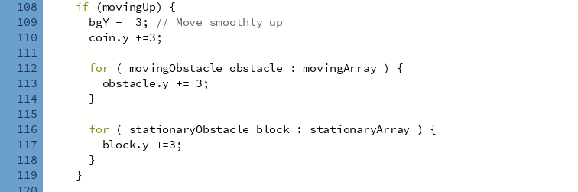

Running my program:

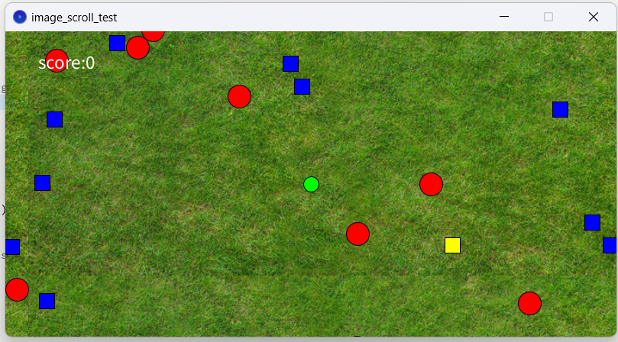  
We can see the coin represented as a yellow square

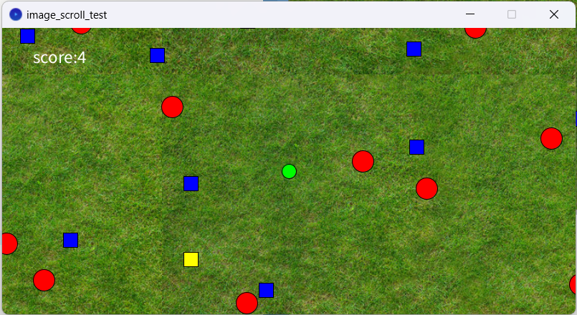

Score increments when I collect the yellow box

Save and read score (file handling) 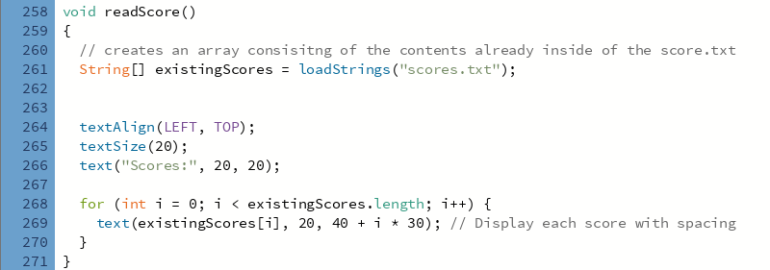

Creates an array consiting of the contents inside my score.txt file. Appends the new score to the array. Then saves this new array into the score.txt adding the new value.

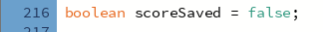

This boolean function will allow it so that the score is only saved once

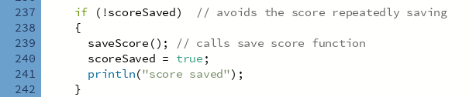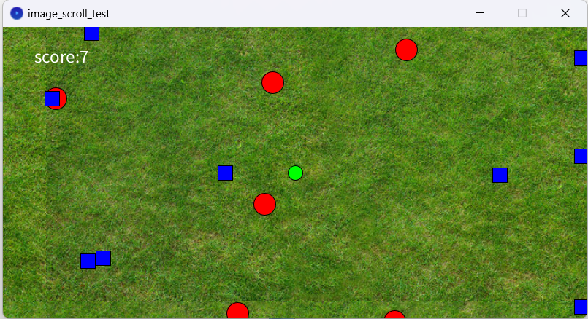  
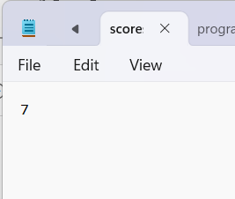  
score correctly saves in my score.txt file

When the player gets a game over i coded it so that the current scores are displayed.   
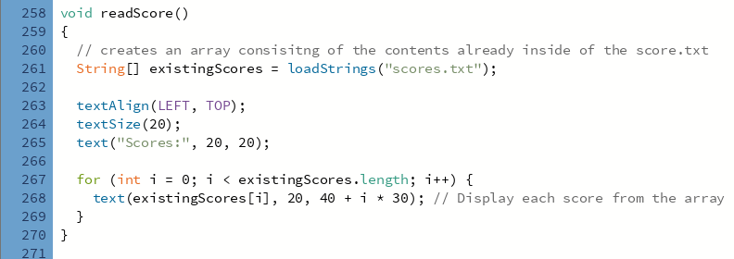  
This function converts the contetns in score.txt into an array then it iterates through each value placing each of them underneath each other.

This function is called when the player gets a game over

Testing this:

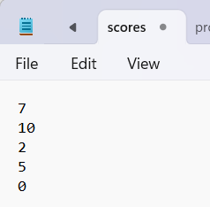  
This is what’s in my score.txt file

This is what appears when the player gets a game over

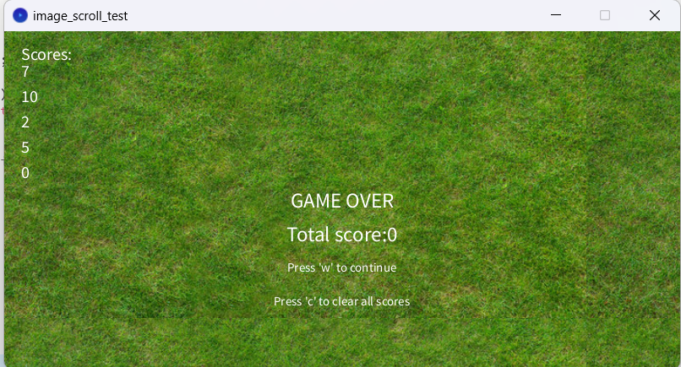

I also added a key bind to clear memory



Version 3  
Features to add:

* Images for player
* Animations
* Add player class to put animations inside it

Adding a Player class and player animations  
As I am going to be giving my player animations, I found it appropriate to make a player class.  
To replicate animation I will be using images.  
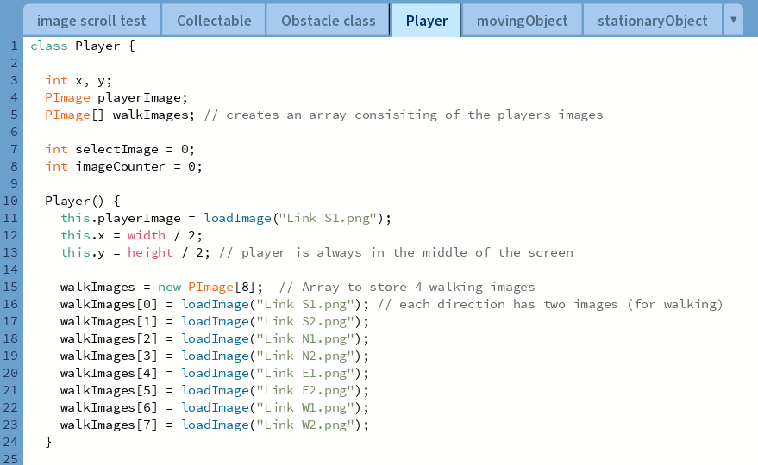

walkImages is an array consisting of all the images ill use for the player. These are the images.  
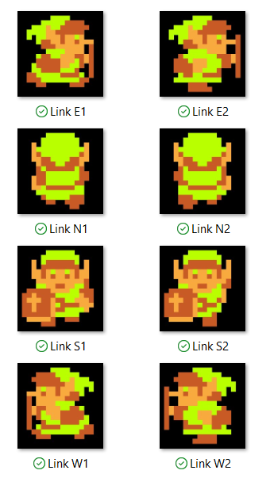  
in my void display method, the image displayed depends on a variable called select Image. Using match case and different index of the walkImages array we can display the correct image when a key arrow is pressed

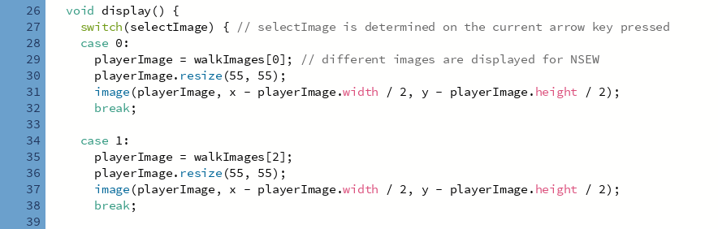

Back in main:

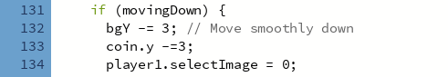

If movingDown is true (which occurs when the down arrow is pressed) the selectImage attribute becomes 0 which means the program will follow case 0 and display “Link S1”.

This code is repeated for the rest of the directions.

When the player moves, I coded it so that two images alternate over a period of time to emulate a walking animation (hence why I have 8 images imported, 2 images per direction).  
  
To do this I made a walkAnimation method in my player class  
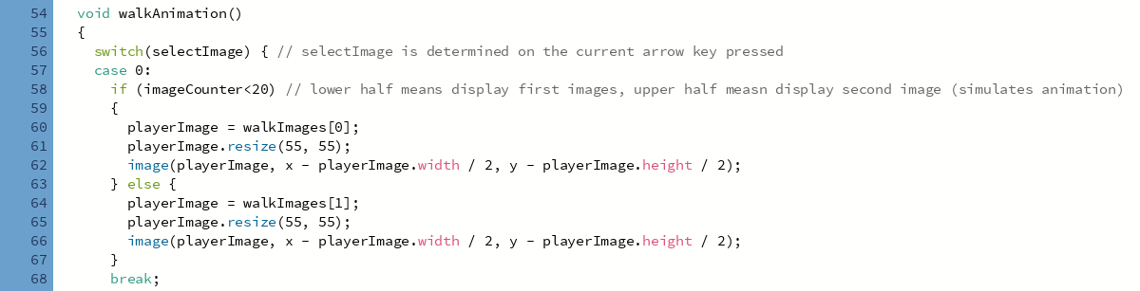

This follows a similar structure to the display method as it determines direction based on selectImage. However, this time we have an imageCounter that increments everytime the function is called. Based on whether the imageCounter is above or below 20 a different image is displayed. This essentially alternates between the two images.

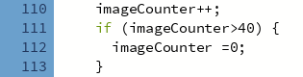

Another difference between this method and the display method is that this method is only called when an arrow key is held down, as it wouldn’t make sense to animate the character if they are not moving.  
  
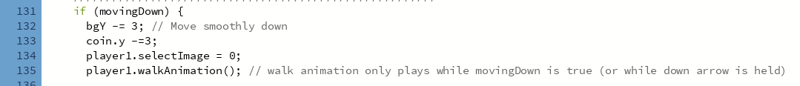

This ensures that the animation only plays when the character is moving  
This code is also pasted for the other directions.  
  
Testing this: *note I changed the background as well  
holding down

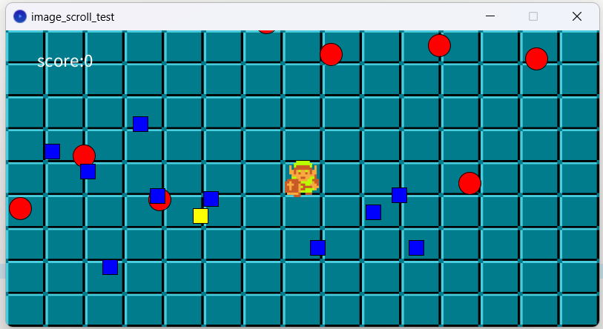

Holding up

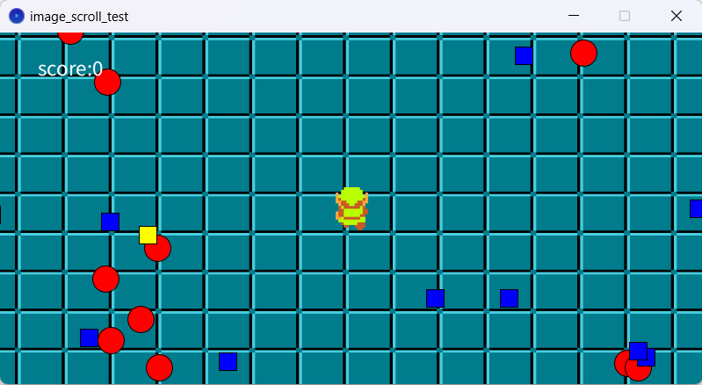

Holding right

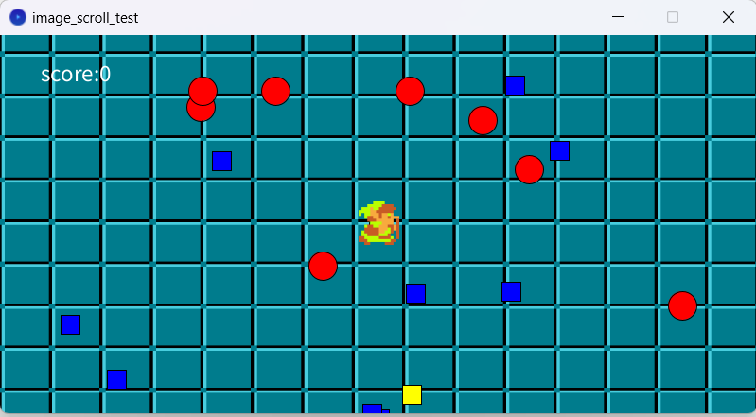

Holding Left

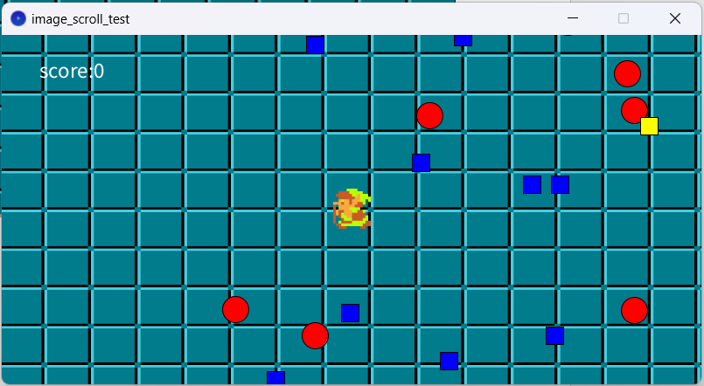

## Animations for obstacles and collectables

I changed my collectable objects display method

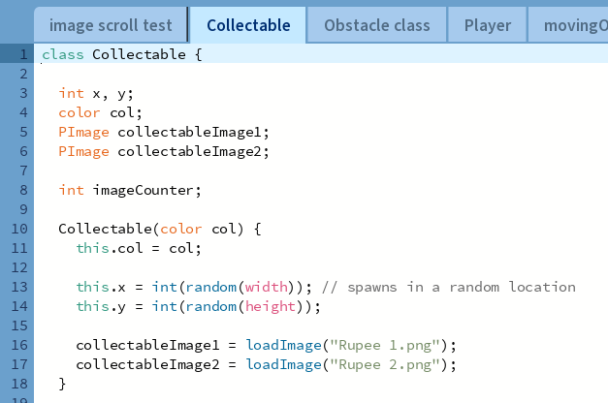

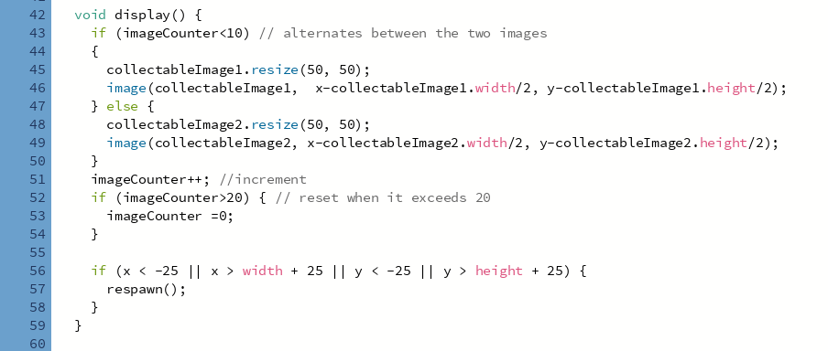

This display method alternates between two images. When image counter is less than 10 is displays image1, when image counter is more than 10 then it displays image 2.  
This simulates a short animation for our collectable object. The images ill be using is this:

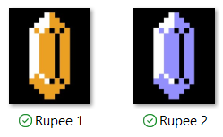

Both my enemy objects will follow the exact same logic and code just with a different image.

stationaryObject images:

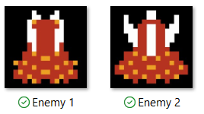

movingObject images:

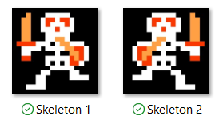

Testing this:

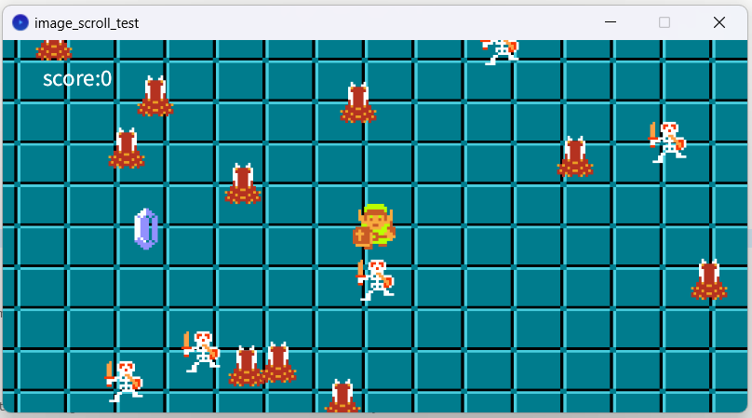

## Death animation

The only animation left to make is a death animation.  
I chose to add a deathAniamtion method in my player class. I wanted my death animation to involve the screen turning gray, the player character will spin and disappear. Graying out the screen and getting rid of the eneimies was essential for effectively communicating a game over.

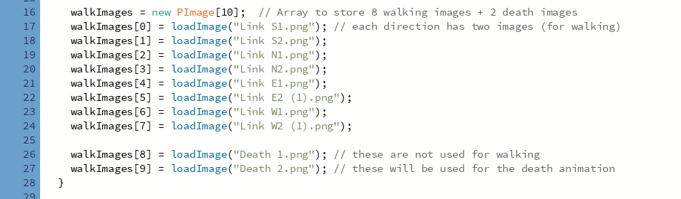

I first added two new images for the characters death animation.

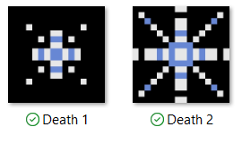

These two images will play consecutively to replicate the character poofing / disappearing

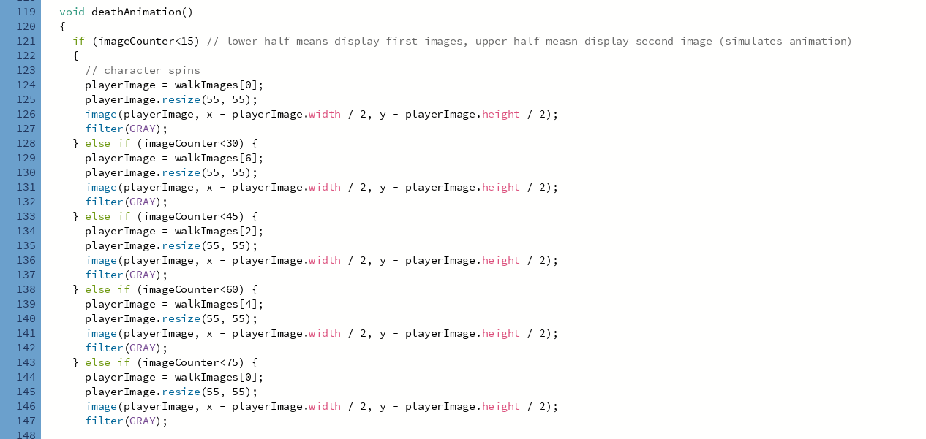

The animation uses the same imageCounter logic, where different images are displayed when image counter is above or below a certain number.  
The code above makes use of our characters NSEW images. Notice how they are filtered gray.

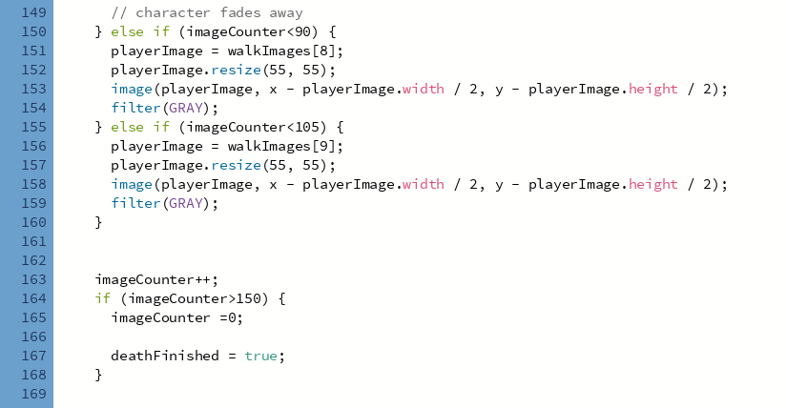

These two else ifs display the disappearing images.   
  
Back in main the game over screen only displays once my deathFInished Boolean becomes true. Once the death animation finishes playing this variable becomes true.



By default, this value is false  
  
Back in main:

This if statement only occurs if gameMode is not 0 (i.e. when the player collides with an obstacles)

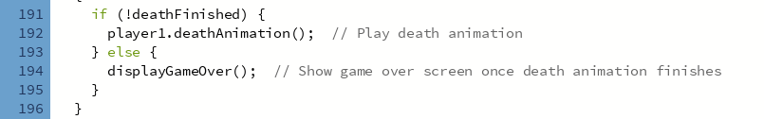

Testing this:

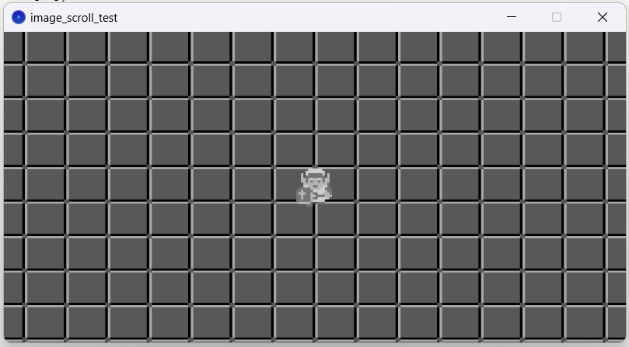  
screen graying out and all objects being destroyed after the player is hit.

Character disappearing animation:

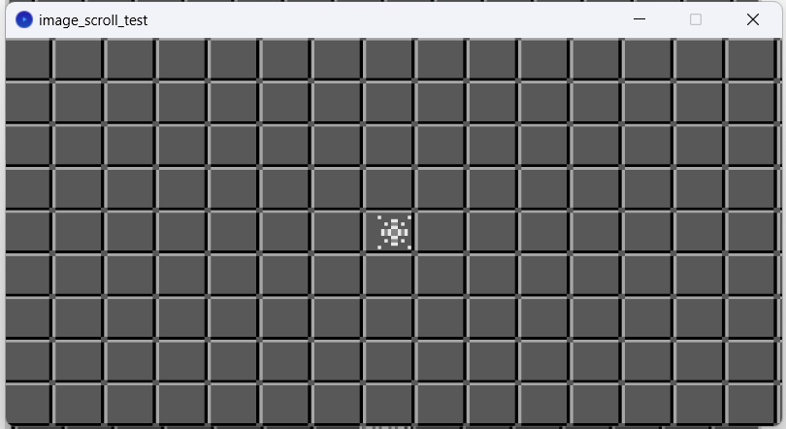

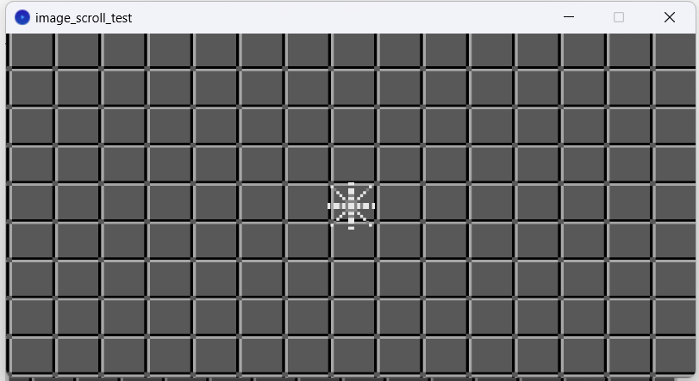

My final change is to make the window just a bit bigger making the game a bit easier to play:

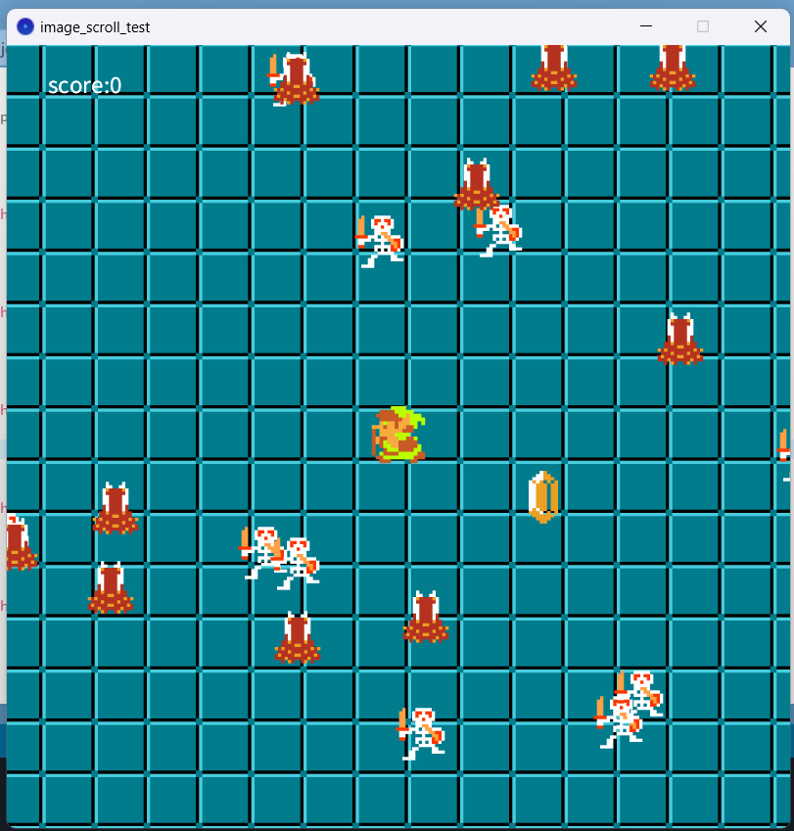

This concludes my 2d game development report. Thank you for reading.